HOSTE D BY

Available online at [www.sciencedirect.com](http://www.sciencedirect.com/science/journal/2314808X)

ScienceDirect

journal homepage: <http://ees.elsevier.com/ejbas/default.asp>

[e gypti an j o ur nal o f b a sic a n d a pp l i ed sci en c e s 2 ( 201 5 ) 1](http://dx.doi.org/10.1016/j.ejbas.2014.12.003) e[12](http://dx.doi.org/10.1016/j.ejbas.2014.12.003)



Full Length Article

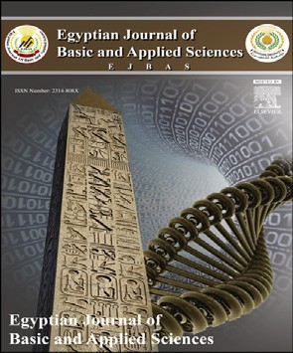Impairment of bone growth of wistar rat fetuses of diabetic and hypercholesterolemic mothers



*Hassan I.H. El-Sayyad* *a**,*\**, Heba A. El-Ghawet* *a**, Mohamed S. Al-Haggar* *b**,*

*Iman H. Bakr* *a**,*\*

a *Department of Zoology, Faculty of Science, Mansoura University, Mansoura, Egypt*

b *Pediatric and Genetic Department, Faculty of Medicine, Mansoura University, Mansoura, Egypt*

## a r t i c l e i n f o

*Article history:*

Received 11 October 2014 Received in revised form 16 December 2014

Accepted 16 December 2014

Available online 31 December 2014

*Keywords:*

Diabetes Hypercholesterolemia Osteoblast

Fetuses TEM

Isoenzymes Apoptosis

## a b s t r a c t

Patients with either diabetes or hypercholesterolemia develop atherosclerosis and impair healing of bone. In the present work we illustrated their role in limb ischemia during bone cells differentiation of Wistar rat fetuses. Pregnant Wistar rats (n = 20 each) were arranged in three groups: control, diabetic or hypercholesterolemic. Diabetes was induced at the fifth day of gestation using streptozotocin, and hypercholesterolemia was carried by feeding virgin rats a diet containing 3% cholesterol for 6 wks prior to the onset of conception. At 13, 15, 17, and 19 d prenatal, pregnant rats were sacrificed, dissected, and fetuses were removed. Hind limbs were separated and subjected to histological and transmission electron microscopic examination, ossification, total calcium content of fetuses, iso- enzymes alkaline and acid phosphatase and lactic dehydrogenase electrophoresis and DNA damage. Fetuses of diabetic or hypercholesterolemic mothers exhibited delayed

histo-cytological differentiation of chondrocytes, and decreased periosteal ossification. Alkaline and acid phosphatase as well as lactic dehydrogenase isoenzymes showed altered diffusion rate and intensities of their bands reflecting their activities in both diseases comparing with the control. Assessments of bone calcium contents revealed marked reduction. Genomic expression of the degree of laddering (total DNA fragmented) or single- cell gel electrophoresis was found to be increased in cartilage and bone cells of fetuses of diabetic or hypercholesterolemic mothers. The authors concluded that both diseases had a selective, dramatic effect during fetus development in this model by retarding the histo- and cytological differentiation during limb bone growth. Both diseases increased the average cell death in skeletal elements and blood vessels as a consequence of altered alkaline and acid phosphatases and lactic dehydrogenase isoenzymes in accordance with DNA damage.

Copyright 2014, Mansoura University. Production and hosting by Elsevier B.V. This is an open access article under the CC BY-NC-ND license ([http://creativecommons.org/licenses/](http://creativecommons.org/licenses/by-nc-nd/4.„0/)

[by-nc-nd/4.0/](http://creativecommons.org/licenses/by-nc-nd/4.„0/)).

* *Corresponding authors*. Experimental Embryology & Nutritional sciences, Faculty of Science, Mansoura University, Mansoura, Egypt. Tel.: +20 01003179778; fax: +20 050 2246254.

E-mail address: [elsayyad@mans.edu.eg](mailto:elsayyad@mans.edu.eg) (H.I.H. El-Sayyad).

Peer review under responsibility of Mansoura University. <http://dx.doi.org/10.1016/j.ejbas.2014.12.003>

2314-808X/Copyright 2014, Mansoura University. Production and hosting by Elsevier B.V. This is an open access article under the CC BY- NC-ND license ([http://creativecommons.org/licenses/by-nc-nd/4.0/](http://creativecommons.org/licenses/by-nc-nd/4.„0/)).

2 [e gypti an j o ur nal o f b a sic and a pp l i ed sci en c e s 2 ( 201 5 ) 1](http://dx.doi.org/10.1016/j.ejbas.2014.12.003) e[12](http://dx.doi.org/10.1016/j.ejbas.2014.12.003)

# Introduction

Hypercholsterolemia represents the common pathogenetic factor for bone disease [1,2]. Researchers are still figuring out exactly how diabetes changes cholesterol levels and contrib- utes to vascular complications such as atherosclerosis [3]. Diabetes [4] or hypercholesterolemia [5] was interrelated with each other and increased the oxidative stress and cell damage. Recently, we reported that maternal diabetic or hyper- cholesterolemic mothers exhibited massive damage of both blood vessels and myocardial fibers of their fetuses [6] as well as induce apparent hepatocyte damage [7] which may co-

operate in bone defects.

A very few number of studies have reported that type 1 diabetes altered bone remodeling by reducing the formation of new bone, leading to osteopenia in humans and animals [8,9]. Type 1 diabetes was found to cause a significant delay in fracture healing [10](Lu et al., 2003) through a reduction of bone mineral density as assessed in the lumbar spine and proximal femur [11] and a decrease of bone formation compared with normal individuals [8].

Experimental studies on diabetic mice and rats revealed that the disease was concerned with reduction of bone for- mation, expression of osteocalcin, collagen types and decrease in bone healing [10], as well as increasing apoptosis of bone- lining cells [11]. Kayal et al. [12] observed a decrease of carti- lage tissue and new bone area post 16 days of onset of diabetes in CD-1 mice. Won et al. [13] examined the inter-vertebral disk of OLETF (diabetic) rats at 6 and 12 months of age and detected increased incidence of apoptotic index of notochordal cells, which led to early intervertebral disc degeneration.

Atherosclerosis, like osteoporosis, is closely associated with each other [1]. The enhanced risk of bone fracture was the end result of accumulated damage [14]. Osteoclast for- mation and function were influenced by numerous inflam- matory factors mediated in atherogenesis such as tumor necrosis factor -a which activated osteoclasts formation [15]. In experimental rats, Funaba et al. [16] reported a reduction of bone formation in 10-week-old hypercholesterolemic rats, suggesting inhibiting factor(s) for bone growth.

From the literature, there are no reports illustrating the direct effects on the differentiation of skeletal cells. The pre- sent study aims to outline the exact role of diabetes or hy- percholesterolemia in histogenesis and cytological structures of bone elements, bone isoenzyme lactic dehydrogenase electrophoresis, and pattern of DNA damage of hind limb of Wistar rat during prenatal growth.

# Materials and methods

### *Induction of diabetes*

Experimental diabetes mellitus was induced by a single intraperitoneal injection of streptozotocin (60 mg/kg) in the citrate buffer (pH 4.5) on the fifth day of gestation [17]. Control animals received physiologic saline as a vehicle. Hyperglyce- mia was verified by measuring the blood glucose at approxi- mately 350 mg/dL.

### *Induction of hypercholesterolemia*

The experimental group was fed a hypercholesterolemic diet according to Enkhmaa et al. [18]. The component of the diet was illustrated in Table 1. The hypercholesterolemic diet was composed of 3% cholesterol and 15% cocoa butter in accor- dance with the standard diet formula. The rats were fed for 6 wks before the onset of gestation. The control group was supplied a standard diet free from atherogenic components.

### *Experimental animal work*

This study and all procedures were approved by the Animal Care and Bioethics of the Egyptian Committee, and the animal work was done at Faculty of Science, Mansoura University. Eighty fertile male and virgin female rats of Wistar strain *(Rattus norvegicus*) (at a ratio of 1 male to 3 females) weighing approximately 125 g body weight, were obtained from Hellwan Breeding Farm, Ministry of Health, Egypt and used for experi- mentation. They were housed in cages with good ventilation on a 12-h light and dark cycle. Females were mated (1 male/3 females) overnight, and zero dates of gestation were deter- mined the next morning by the presence of sperm in the vaginal smear. The pregnant rats were arranged into three

groups (n = 20 per each) as follows: C, control; D, diabetic; H,

hypercholesterolemic. Animals were maintained in free excess of diet as mentioned in Table 1 and water *ad Libitum*. At the end of treatment, they were sacrificed by light diethyl ether anes- thesia and dissected at 13, 15, 17, and 19 d prenatal. The tibia regions from hind limbs were separated immediately from 13, 15, 17, and 19 d-old embryos and investigated as follows:

### *Light microscopic investigations*

Hind limb of fetuses of both control and experimentally- treated fetuses were incised at 13-&15d-old and fixed in 10% phosphate buffered formalin (pH 7.4), dehydrated in ascending grades of ethyl alcohol, cleared in xylene and

|  |  |
| --- | --- |
| Table 1 e Description of the percentages of diets constituents in control, diabetic and hypercholesterolemic groups. | |
| Ingredient (%) | Control Diabetic Hypercholesterolemic |
| Crude protein | 16 16 14 |
| Butter fat, | 4 4 10 |
| anhydrous |  |
| Choline bitartrate | 1 1 1 |
| Cholesterol | e e 3 |
| Cholic acid | e e 2 |
| Thiouracil | e e 2 |
| Cellulose | 13 13 13 |
| Casein | 10 10 15 |
| Soybean oil | 5 5 15 |
| Vitamins | 2.5 2.5 2.5 |
| Minerals | 2.5 2.5 2.5 |
| Moisture | 7 7 7 |
| Ash | 4 4 3 |
| Sucrose | 10 10 5 |
| Carbohydrates | 10 10 5 |
| Corn starch | 15 15 5 |

[e gypti an j o ur nal o f b a sic a n d a pp l i ed sci en c e s 2 ( 201 5 ) 1](http://dx.doi.org/10.1016/j.ejbas.2014.12.003) e[12](http://dx.doi.org/10.1016/j.ejbas.2014.12.003) 3

mounted in molten paraplast at 58e62 ◦C. Serial 5-mm histo- logical sections were cut and stained with hematoxylin and eosin and examined under bright-field light microscopy.

### *Transmission electron microscopic investigations*

Tibia specimens of 15d-old fetuses of both control and experimental groups were separated and fixed immediately in 2% glutaraldehyde in 0.1 M cacodylate buffer (pH 7.4) for 12 hours. After washing, the specimens were postfixed in a buffered solution of 1% osmium tetra oxide at 4 ◦C for 1.5 h,

dehydrated in ascending grades of ethyl alcohol, and embedded in epoxyeresin. Ultrathin sections were cut with a diamond knife on an LKB Ultratome IV (LKB Instruments, Bromma, Sweden) and mounted on grids, stained with uranyl acetate and lead citrate, and examined under a Joel 100CX transmission electron microscope (Musashino 3-chome Akishima Tokyo 196- 8558, Japan).

### *Ossified length of femur, tibia and fibula*

The ossification centers of hind limb of examined fetuses were careful staining with the alizarin red “S” method. The lengths of ossified femur, tibia and fibula were measured for ten fetuses per each developmental stage in all groups.

### *Determination of calcium in fetuses*

Calcium content was assayed in fresh fetuses (n = 10) from both the control and experimental groups at 15,17 and 19-days prenatal. The fetuses were dissected and remove all the in- ternal organs and dried in aven at 60 ◦C for 6 hours. Lipid extraction was carried out by using chloroform methyl mixture 2:1. The fetuses' skeleton were weighed and digested

in 1 mL of nitric acid at highest purity and diluted with 4 mL bi-

distilled water and measure calcium by atomic absorption spectrometry [19].

### *Lactate dehydrogenase and alkaline and acid* phosphatases isoenzymes electrophoresis

For determination of lactate dehydrogenase (LDH; 3.1.1.27), tissues were homogenized and centrifuged at 3000 × *g* for 5 min, 4 ◦C. One mL protein dye (0.001% bromophenol blue)

plus 20 mL 2% sucrose were added and thirty mL of the mixture per gel slot was applied for each sample in enzyme electro- phoresis. Polyacrylamide gel electrophoretic profiles of LDH isoenzymes were utilized and software analysis of gel scans done. Electrophoresis was essentially carried out according to Lehnert and Berlet [20]. LDH enzyme bands were stained and visualized in the presence of L-lactate as the substrate ac- cording to the procedure of Shaw and Prasad [21]. Then, the stained gels were fixed in 7% acetic acid (v/v) and documented via scanning on HP Deskjet F370 All-in-One computer as- sembly. Limb ALP is separated by electrophoresis through alkaline buffered (pH 9.1) according to [22]. Electrophoresis was performed at a constant current at 2.5 mA per gel column

at 18e20◦C. Incubation for alkaline phosphatase (E.C.3.1.3.1)

was carried out using Naphthol-AS-MX-phosphateas sub- strate and fast red violet LB salt as the coupler. Incubations of

acid phosphatase (E.C.3.1.3.2) was undertaken at pH 5.0 using alpha-naphthyl phosphate as substrate and hexazotized pararosanilin as coupled agent, run in electrophoresis and processed for visualization and photographed [23].

### *DNA fragmentation assay*

DNA fragmentation was assayed by a modification of Duke and Sellins [24]. Freshly isolated specimens were washed twice with ice-cold phosphate-buffered saline and suspended in 100 mL lysis buffer (10 mM Tris HCl/10 mM EDTA/0.5% Triton X-100, pH 8.0), vortex-mixed, sonicated, and incubated on ice for 20 min. After centrifugation at 4 ◦C (14,000 × g), the supernatant containing fragmented (soluble) DNA was mixed with lysis buffer (1 mL). Both samples were treated with

RNAse A (0.5 mg/mL) for 1 h at 37 ◦C and then with proteinase- K (0.4 mg/mL; Sigma, St. Louis, MO, USA) for 1 h at 37 ◦C. After adding 20 mL of 5 M NaCl and 120 mL isopropanol, the samples were incubated overnight at 220 ◦C, and the DNA concentra- tions were determined and run on agarose gel electrophoresis

and visualized.

### *Single cell gel electrophoresis (Comet assay)*

Specimens of both control and experimental diseased groups were homogenized in chilled homogenizer buffer (pH 7.5) containing 75 mM NaCl and 24 mM Na2EDTA (pH 13), to obtain a 10% tissue solution. Six mL of the homogenate was sus- pended on 0.5% low melting agarose and sandwiched between a layer of 0.6% normal-melting agarose and a top layer of 0.5% agarose on fully frosted slides. The slides were kept on ice during the polymerization of each gel layer. After solidifica- tion, the slides were immersed in a lysis solution (1% sodium

surcosinate, 2.5 m NaCl, 100 mM Na2EDTA, 10 mm TriseHCl, 1% Triton X-100, and 10% DMSO) at 4 ◦C for 1 h, then placed in electrophoresis buffer to allow DNA to unwind. Electropho- resis was performed for 10 min at 300 mA and 1 V/cm. The

slides were neutralized with Tris HCL buffer, pH 7.5, and stained with 20 mg/mL ethidium bromide. Each slide was analysed using a Leitz Orthoplan (Wetzlar, Germany) epi- fluorescence microscope. One hundred cells were analysed on each slide using the Comet assay II automatic digital analysis system [25].

### *Statistical analysis*

Statistical analysis was carried out between the control and each experimental group and for each developmental stage. Means and standard deviations were calculated for each result. Student's t test was applied and the differences were considered statistically significant from the control at

P < 0.05.

# Results

### *Light and ultrastructural observations*

At light microscopic level, control 13-d old embryos exhibited the presence of ossification centers in the center of the diaphysis of both femur and tibia. The extra parts of the

4 [e gypti an j o ur nal o f b a sic and a pp l i ed sci en c e s 2 ( 201 5 ) 1](http://dx.doi.org/10.1016/j.ejbas.2014.12.003) e[12](http://dx.doi.org/10.1016/j.ejbas.2014.12.003)

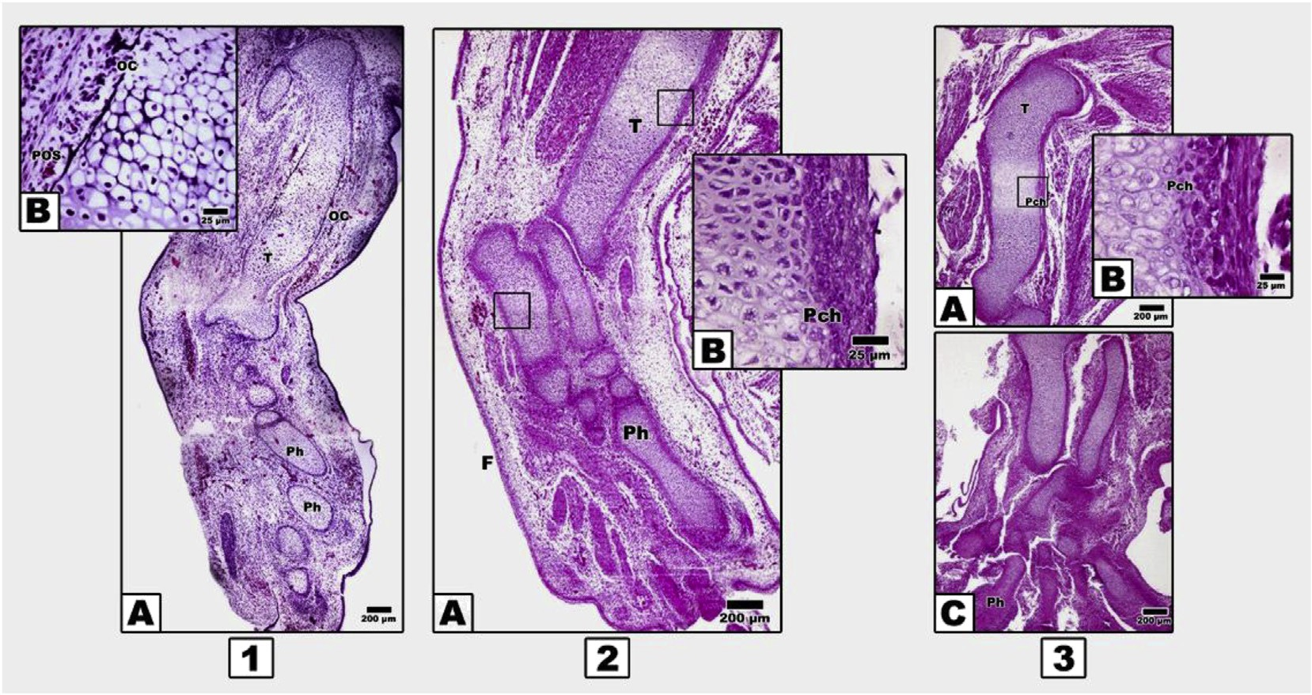

Fig. 1 e Photomicrographs of histologic sections of hind limb of 13 d-old embryos. Inset B in each image (1e3) represents a magnification of A in the respective image. 1. Control, A. Tibia with primary ossification centers and phalanges with hypertrophied chondrocytes. 2. Fetuses maternally diabetic, A. Shows chondrification of tibia and phalanges. 3. Fetuses maternally hypercholesterolemic, A and C. Show chondrified tibia and phalanges. Abbreviations: F: foot; OC: ossification centres; Pch: perichondrium; Ph: phalanges; POS: periosteal ossification; T: tibia.

mentioned regions as well as tarsal, metatarsal and phalanges showed marked chondrification. The femur and tibial shafts were ensheathed by perichondrium sheath, several cell layers thick except the ossification centers, where sprouts of osteo- blast progenitor cells become invade. The mid tarsal, meta- tarsal and phalanges possessed the presence of hypertrophied cartilage cells (Fig. 1 1A & B).

In contrast, 13 d-old embryos of both diabetic or hyper- cholesterolemic mothers exhibited delayed chondrification of both femur, tibia and distal tarsal, metatarsal and phalanges compared with the control. There is a marked comparatively reduced periosteal ossification centers in both femur and tibia (Fig. 2 2AeC).

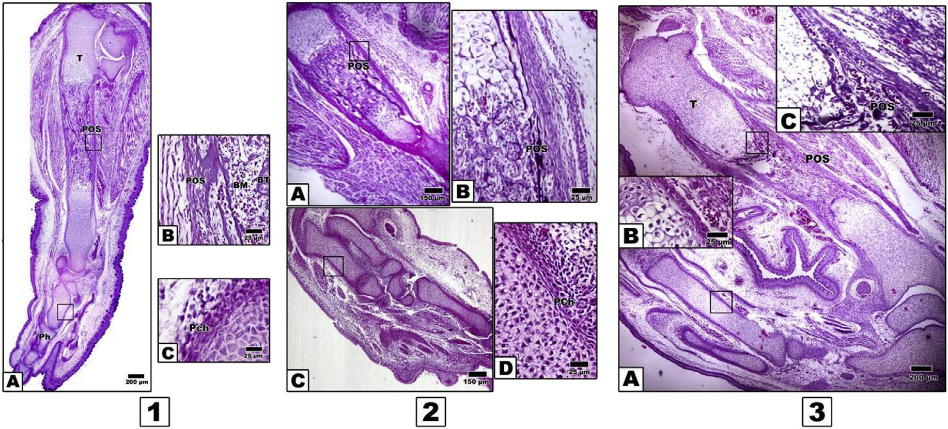

Fig. 2 e Photomicrographs of histologic sections of hind limb of 15 d-old embryos. 1. Control, A. Periosteal ossification of tibia and phalanges. B. Periosteum and bone invasion. C. Increased cellularity of perichondrium of phalanges. 2. Fetuses maternally diabetic, A. Tibia showing decreased mineralization of calcified tibia. B. Periosteal bone invasion. C. Decreased chondrification of phalanges. D. Delayed development of both perichondrial sheath and chondrocytes. 3. Fetuses maternally hypercholesterolemic, showing decreased ossification of tibia (A and C) and chondrified phalanges (B). Abbreviations: BM: bone marrow; BT: bone trabecula.

[e gypti an j o ur nal o f b a sic a n d a pp l i ed sci en c e s 2 ( 201 5 ) 1](http://dx.doi.org/10.1016/j.ejbas.2014.12.003) e[12](http://dx.doi.org/10.1016/j.ejbas.2014.12.003) 5

In control 15 d-old embryos, ossification proceeded in different parts of hind limb regions, with characteristic regular arrangement of cartilages zones within the limb regions. The ossification centers proceeded with marked

progress of dark-brown deposits of mineralized calcium salts (Fig. 2, 1AeC). In contrast, 15 d-old embryos of either diabetic or hypercholsterolemic mothers exhibited comparatively reduction of ossification centers in

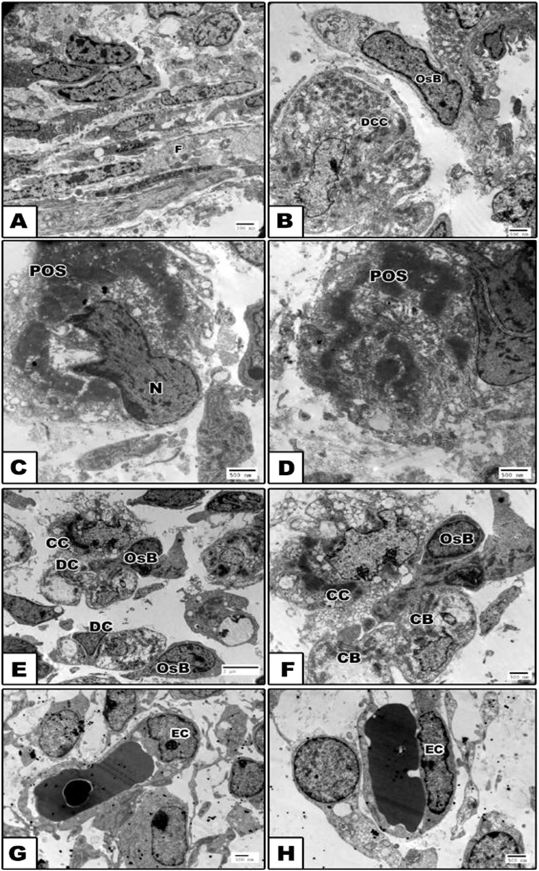

Fig. 3 e Transmission electron micrographs of tibia of control 15 d-old embryo. A. Periosteal sheath formation. B. Osteoprogenitor cells in close proximity to degenerated chondrocytes. C and D. Abundant distribution of mineralized calcium deposits at the peripheral surface of degenerated chondrocytes. E and F. Numerous osteoblast cells in between degenerated chondrocytes. G and H. Normal blood vessel within periosteal sheath having normal endothelial lining cells. Abbreviations: CB: chondroblasts; CC: chondrocyte; DC: degenerated chondrocytes; DCC: degenerated cartilage cells; EC: endothelial cells; F: fibroblast; N: nucleus; OsB: osteoblasts; POS: periosteal ossification.

6 [e gypti an j o ur nal o f b a sic and a pp l i ed sci en c e s 2 ( 201 5 ) 1](http://dx.doi.org/10.1016/j.ejbas.2014.12.003) e[12](http://dx.doi.org/10.1016/j.ejbas.2014.12.003)

comparison with the control. Chondrification of the distal phalanges was detected but not matched with the control (Fig. 2, 2A-D and 2, 3AeC).

At the ultra-structural level, the control tibia of 15d-old fetuses possessed electron-dense mineralization calcium salts within the periosteum and in-between the hypertro- phied chondrocytes. The periosteal sheath showed densely grouping fibroblast cells and characteristic bundles of collagen fibers. Nests of macrophages and osteoblast cells representing osteoprogenitor cells were detected closely adjacent to the calcified matrix of the breakdown chon- drocytes. The osteoblast was characterized by the presence of a well-developed rough endoplasmic reticulum with dilated cisternae and large circular Golgi complex containing multiple stacks (Fig. 3 AeH).

In contrast, embryos of either diabetic or hypercholester-

olemic mothers exhibited malformed perichondrial sheath with peculiar presence of fibroblast cells lacking the cyto- plasmic dendritic formation. The chondrocytes possessed vacuolated cytoplasm and presence of collagen fibers. Many of the chondrocytes attained considerable hypertrophy with the massive breakdown of their cytoplasmic compartments and nuclei with clumping of their nuclear chromatin (apoptosis) (Figs. 4 AeF and 5 AeH).

### *Ossified length of femur, tibia and fibula*

From Figs. 6 and 7, the ossified length of femur, tibia and fibula of 15e19d-old fetuses of diabetic and hypercholesterolemic mothers showed a marked decrease comparing with the control.

### *Fetuses calcium content*

From Fig. 8, fetuses of diabetic and hypercholesterolemic mothers showed a marked reduction of calcium content.

### *Differential isoenzyme alkaline and acid* phosphatase and lactic dehydrogenase activity

Three bands of alkaline phosphatase isoenzymes are expressed in control bone specimens of 15,17 and 19 d-old fetuses. The rate of diffusion was markedly increased in fetuses of diabetic and hypercholesterolemic mothers, especially at 17 d-old. Isoenzyme fraction III appeared missing in 19 d-old diabetic and hypercholesterolemic fetuses. On the other hand, the intensity of acid phosphatase isoenzymes was markedly reduced. Separation of the isoenzyme and formation of the double band was

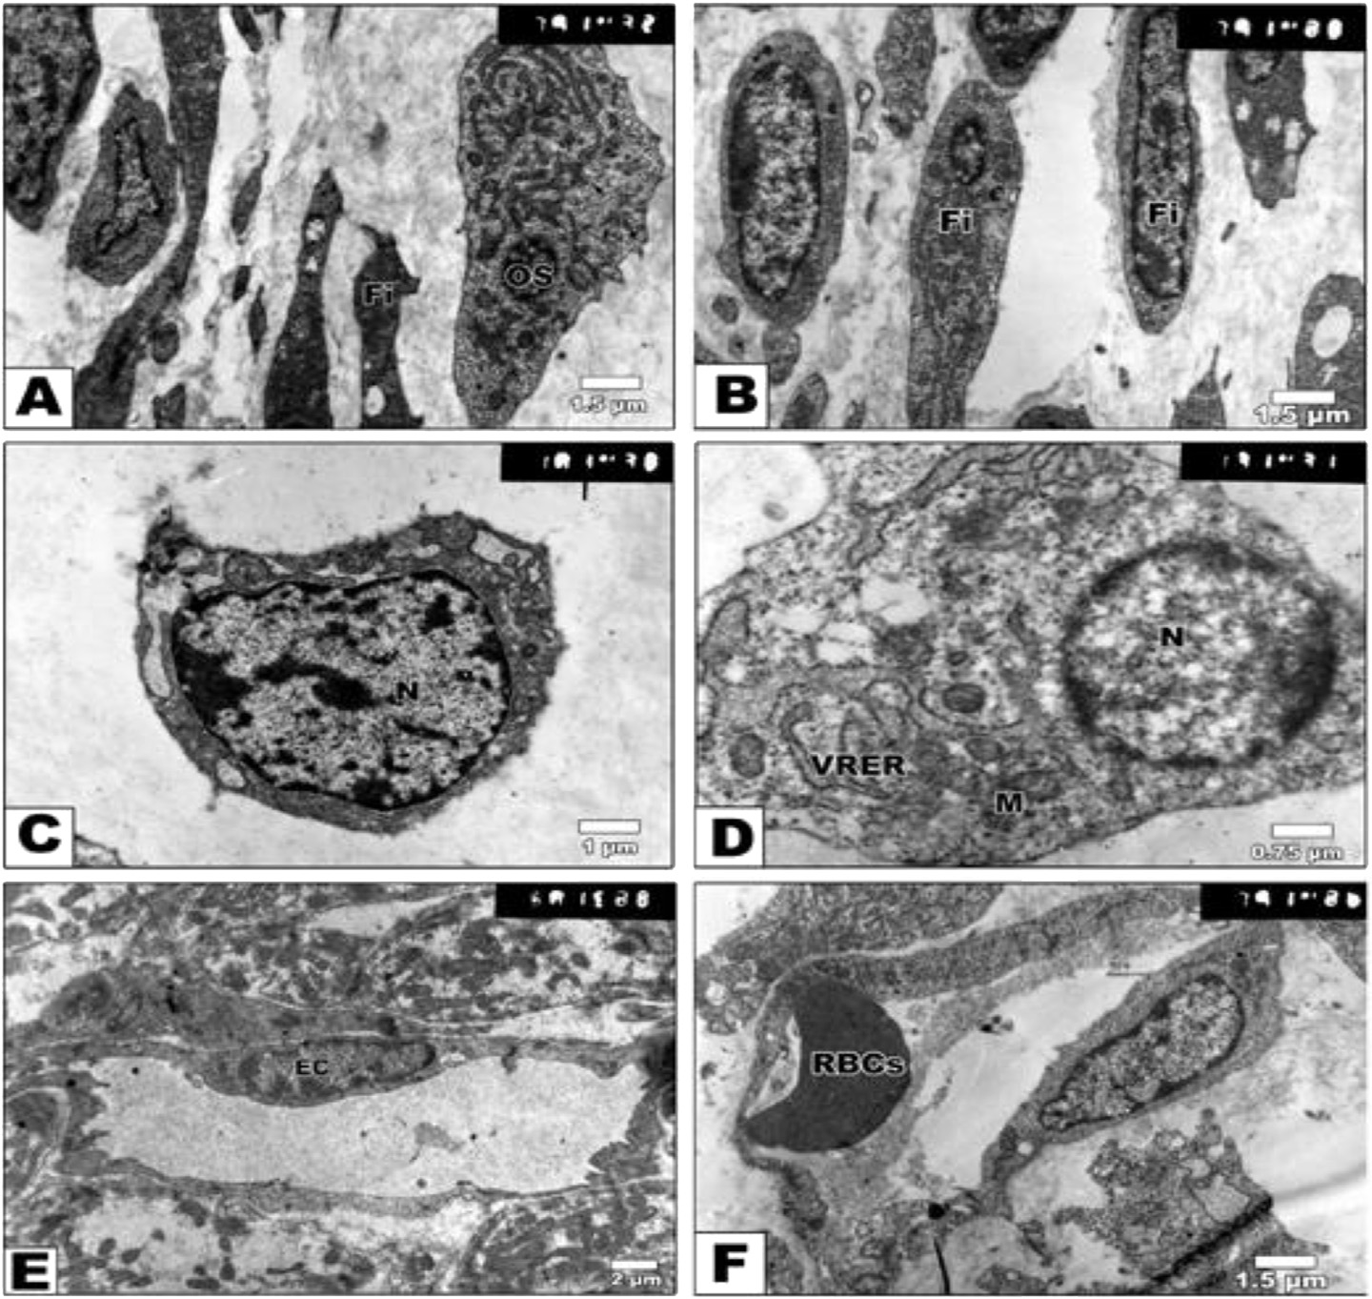

Fig. 4 e Transmission electron micrographs of tibia of 15 d-old embryo maternally diabetic. A and B. Damaged fibroblast cells forming perichondrium. C. Chondrocytes with characteristic nucleus and thin cytoplasm. D. Damaged chondroblast having cytoplasm with vesicuolated rough endoplasmic reticulum and electron-dense mitochondria. E and F. Swollen blood vessel with lining of the endothelium having abundant heterochromatin. Abbreviations: Fi: fibroblast; M: mitochondria; RBCs: red blood cells; VRER: vesicuolated rough endoplasmic reticulum.

[e gypti an j o ur nal o f b a sic a n d a pp l i ed sci en c e s 2 ( 201 5 ) 1](http://dx.doi.org/10.1016/j.ejbas.2014.12.003) e[12](http://dx.doi.org/10.1016/j.ejbas.2014.12.003) 7

detected in 19 d-old fetuses of diabetic or hypercholester- olemic groups (Fig. 9).

The cartilage and bone elements lactic dehydrogenase express five isoenzymes (LDH1-LDH5) (Fig. 10A). Both diabetes or hypercholesterolemic groups exhibited either no expres- sion of their isoenzyme bands or a decrease in its intensity in 15 d-old embryos. The expression of isoenzymes was mark- edly detected in 17 and 19 d-old tibia of embryos of diseased groups. However, double bands of isoenzyme IV were clearly detected in hypercholesteromic-groups as well as increased intensities of the expression of fraction V.

### *Genomic DNA fragmentation*

The genomic expression of the degree of laddering (total DNA fragmented) increased in cartilage and bone cells of fetuses maternally diabetic or hypercholesterolemic. The highest incidence of genomic DNA fragmentation was markedly increased in skeletal cells of diabetic mothers (Fig. 10B).

Also, following application of the Comet assay (single-cell gel electrophoresis), the single-strand nucleotide/each skel- etal cell of fetuses of both diabetic or hypercholesterolemic mothers were streached with increased tail length and DNA

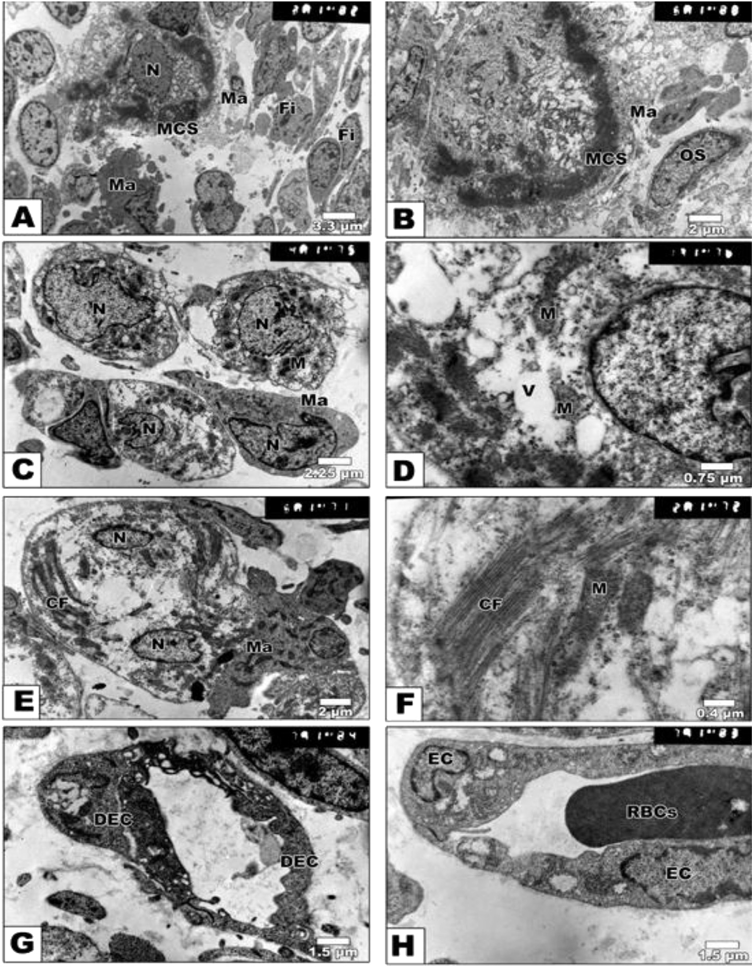

Fig. 5 e Transmission electron micrographs of tibia of 15 d-old embryo maternally hypercholesterolemic. A and B. Mineralized calcium deposits at periphery of osteocytes and surrounded by macrophages. C and D. Macrophage in between chondrocytes. The cytoplasm shows abundant mitochondria and collagen bundles. E and F. Hypertrophied chondrocytes with cytoplasm rich in mitochondria and collagen fibres. G and H. Abnormal blood vessel within degenerated endothelial lining cells. Abbreviations: CF: collagen fibres; DEC: degenerated endothelial cells; M: mitochondria; Ma: macrophage; MCS: mineralized calcium salts; N, nucleus; Os: osteoblast; V: vessel.

8 [e gypti an j o ur nal o f b a sic and a pp l i ed sci en c e s 2 ( 201 5 ) 1](http://dx.doi.org/10.1016/j.ejbas.2014.12.003) e[12](http://dx.doi.org/10.1016/j.ejbas.2014.12.003)

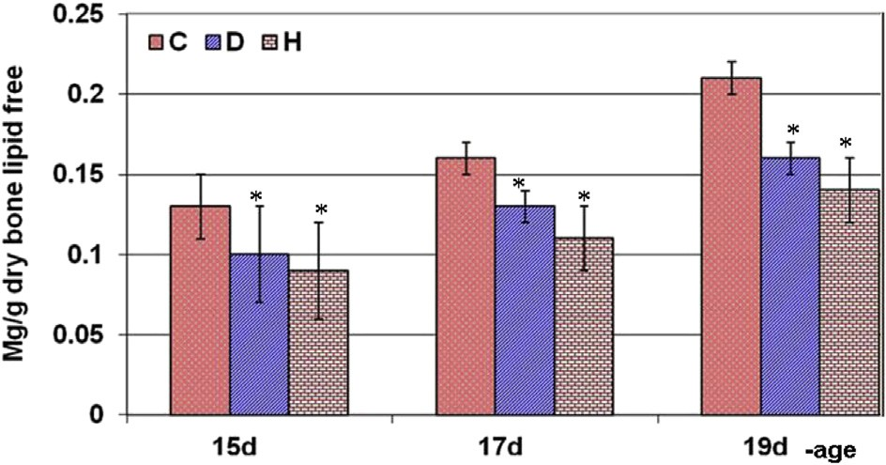

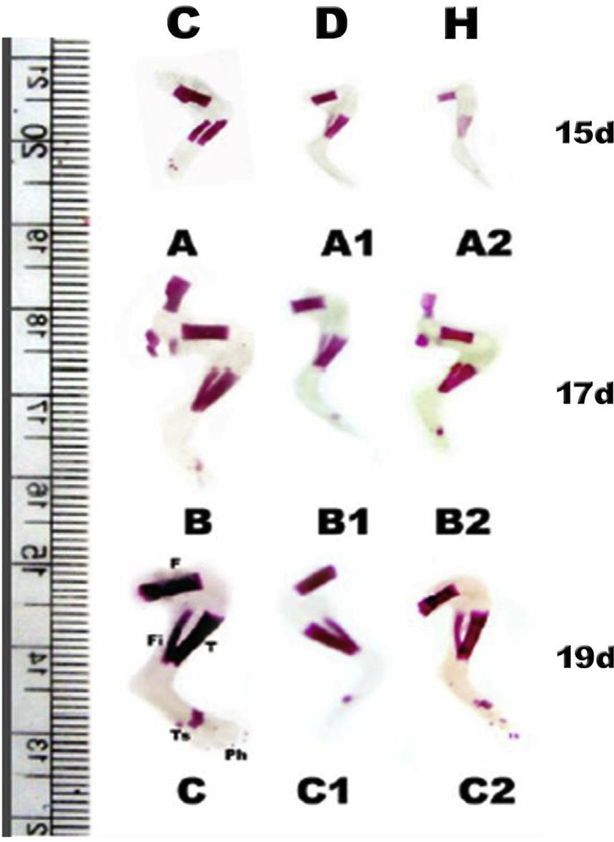Fig. 6 e Lateral view photomacrograph of hind limb of Alizarin red S preparation of 15, 17 and 19 d fetuses of diabetic and hypercholesterolemic mothers. A, A1 &A2. Control 15,17 & 19d-old.B, B1&B2. 15,17 &19d-old fetuses maternally diabetic. C, C1 &C2. 15,17 &19d-old fetuses maternally hypercholesterolemic. Note reduction of ossified femur & tibio-fibula in experimental groups.

Fig. 8 e Calcium content of skeleton of 15, 17, and 19 d-old fetuses maternally diabetic or hypercholesterolemic.

Numer of fetuses/group (n ¼ 10). *.Means significant at P

P < 0.05 student t test.

concentration, compared with normal pattern structure manifesting apoptic cell death (Fig. 11).

# Discussion

Maintenance of skeletal integrity involves a dynamic biolog- ical equilibrium between osteoclast-induced bone resorption and osteoblast-mediated bone formation. Ossification of the limb is carried throughout the endochondral period [26]. Ac- cording to Polanco Ponce et al. [27], maternal diabetes in rats was found to alter fetal development in a very similar manner to that of humans.

The observed findings are the first to reveal that the developing rat fetuses at 13 d-old prenatal of either diabetic or hypercholesterolemic mothers showed a marked delay of histogenesis of perichondrium and periosteal ossification of hind limb. There was a qualitative decrease of both mineral- ized calcium salts and cartilage-bone formation. Ultra- structurally, both chondroblast and osteoblast cell's differen-

tiation were markedly delayed associated with deformed

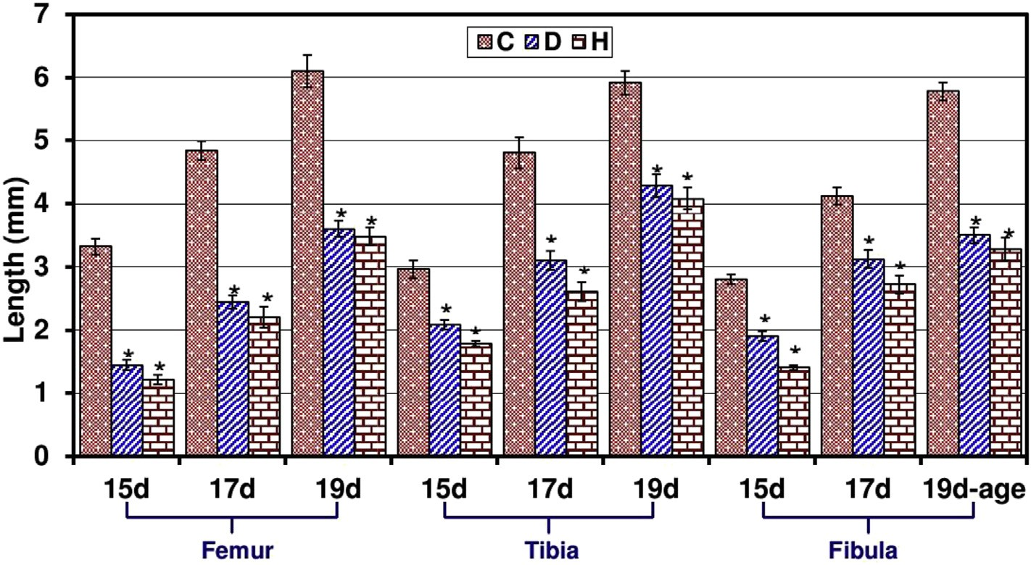

Fig. 7 e Ossified length of femur, tibia and fibula of Alizarin red S preparation of 15, 17 and 19 d fetuses of diabetic and hypercholesterolemic mothers. Numer of fetuses/group (n ¼ 10). *.means significant at P P < 0.05 student t test.

[e gypti an j o ur nal o f b a sic a n d a pp l i ed sci en c e s 2 ( 201 5 ) 1](http://dx.doi.org/10.1016/j.ejbas.2014.12.003) e[12](http://dx.doi.org/10.1016/j.ejbas.2014.12.003) 9

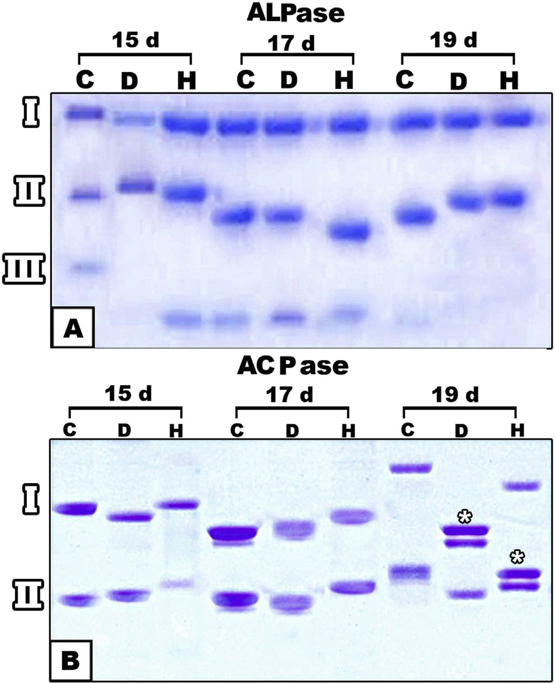

Fig. 9 e Alkaline (A) and acid (B) isoenzyme electrophoresis of tibia of 15, -17-, and 19 d-old fetuses maternally diabetic or hypercholesterolemic shows increased intensity in hypercholesterolemic fetuses and decreased flow rate and activity intensities in diabetic fetuses.

osteoprogenitor cells within the periosteum sheath, predict- ing the primitive osteoid bone formation. The observed cyto- logical findings were confirmed by a marked decrease of the ossified length of limb bones as well as decreased mineralized calcium salts in the skeleton of 15, 17 and 19-d old fetuses of diabetic or hypercholesterolemic mothers.

The present findings support the work of Eidem et al. [28] and El-Sayyad et al. [29], who studied the effects of either diabetes or hypercholesterolemia in pregnant mother and their offspring. Our findings declare that decreased ossifica- tion resulted from a reduction of calcium contents of embry- onic bone tissues. Ossification defects may be attributed either to disruption of either the Ca2 supply or the bone maturation itself [30], or decreased placental transport ca- pacity [31]. The ossification process in the fetus itself was deficient, as indicated by decreased osteocalcin levels [32]. Retarded both bone growth [33,34] as well bone marrow osteogenic progenitor cells [35] were the main consequences of diabetes. Also, the mentioned authors mentioned that diabetes cause a significantly decrease in levels of chondroitin sulphate and heparan sulphate in the vertebrae of ovariecto- mized diabetic rats. Both chondroitin sulphate and heparan sulphate represent the main sources of cartilage and bone formation [36]. Violation of the oxidant/antioxidant balance by high glucose concentrations can cause massive cell dam- age, increase in apoptotic events and defective embryonic development [37,38]. Viccica et al. [39] reported that

cholesterol was synthesized by the liver and secreted as circulating lipoproteins and plays a role in osteoblast differ- entiation. Also, bone growth defects may be attributed to the pathogenesis of non-alcoholic steatohepatits induced by hy- percholesterolemia [7] as mentioned by Nakano et al. [40]. The liver represents the main target of conversion of cholecalcif- erol (vitamin D3) to 25-hydroxyvitamin D3 as well as 25- hydroxyvitamin D2 [41] which regulating the concentration of calcium and phosphate in the bloodstream and promoting remodeling of bone [42]. Liver damage may disrupt bone dif- ferention through reducing vitamin D synthesis.

From our findings, diabetes or hypercholesterolemia exhibited missing expression of lactic dehydrogenase isoen- zyme III in 15 d-old embryos. However, double bands of isoenzyme IV were clearly detected in hypercholesteromic- groups as well as increased intensities of the expression of fraction V. These alterations of the isoenzymes reflect alter- ations of their metabolic activities and may share in bone cell's damage. Lactate dehydrogenase (LDH) has been used

extensively as a marker for cell death both *in vitro* and *in vivo*

[43]. It is more active in osteocytes [44]. Also dehydrogenases except (glutamic dehydrogenase) were detected in osteocytes, osteoblasts and osteoclasts in mandible of 5 day old rat. The bone cells possess fully functional citric acid cycles, pentose cycles, and the capacity to metabolize fatty acids and carbo- hydrates [45]. Experimental diabetes was found to be associ- ated with alterations of oxidative and glycolytic enzymes, including lactic dehydrogenase [46].

Also, there was a marked alterations of bone alkaline and acid phosphatase isoenzymes. The isoenzyme fraction III of alkaline phosphase showed increased diffusion rates and missing in 19 day-old fetuses. Acid phosphatase isoenzymes showed marked reduction of their intensities and increase diffusion rate. Bone-alkaline phosphatase is a useful param- eter for monitoring changes in bone formation [47]. The dis- tribution of acid and alkaline phosphatase activity were identified in osteoclasts and adjacent osteocytes extracellu-

larly lining Howship's lacunae in endosteal resorbing surfaces

of rat tibia [48].

Also, feeding on diet high of cholesterol level revealed a reduction of its utilization by fetal tissues, impairing growth and consequently increasing the incidence of developmental defects, including morphological and delayed ossification of bones. The estimated ossified length of hind limb in fetuses of hypercholesterolemic mothers showed apparent reduction. The fetal growth defects may be associated with the damage of myocardium and the development of atherosclerosis in blood vessels, which reduces the transport of nutrients and oxygen to tissues, as well as the cytotoxicity of hypercholes- terolemia [6].

There a close association between both diabetes [49] or hypercholesterolemia [50] and disruption of vitamin D syn- thesis via decrease serum concentrations of 25- hydroxycholecalciferol which intern impair bone cell differentiation.

Also, there was a detected increase of DNA fragmentation in bone tissues of fetuses of either hypercholesterolemic or diabetic mothers. Chronic diabetes is one of the causes of reactive oxygen species formation [51] where the cellular response to reactive oxygen species led to the formation of

10 [e gypti an j o ur nal o f b a sic and a pp l i ed sci en c e s 2 ( 201 5 ) 1](http://dx.doi.org/10.1016/j.ejbas.2014.12.003) e[12](http://dx.doi.org/10.1016/j.ejbas.2014.12.003)

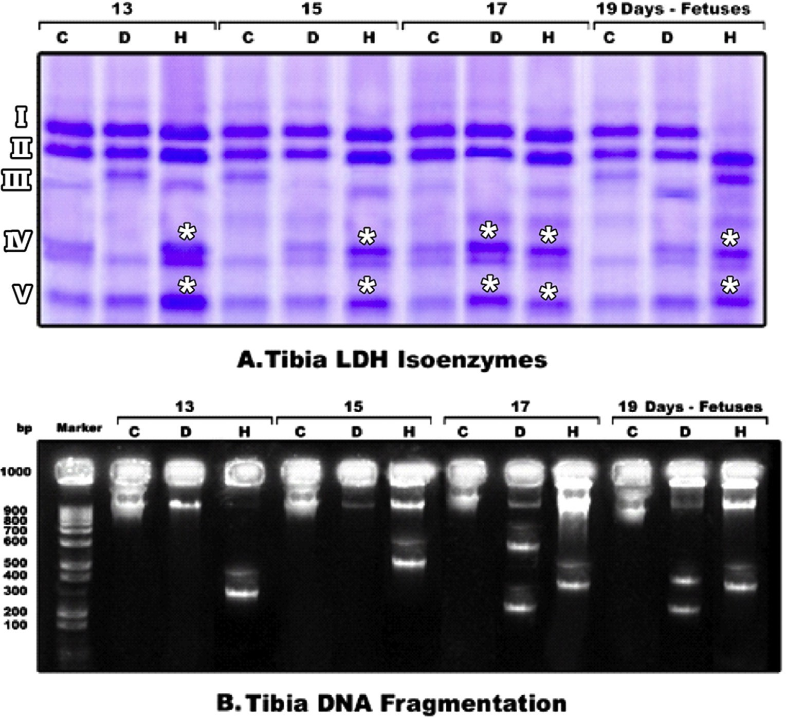

Fig. 10 e A. Lactic dehydrogenase isoenzyme electrophoresis pattern of tibia of 13-, 15-, 17-, and 19 d-old fetuses maternally diabetic or hypercholesterolemic shows increased intensity in hypercholesterolemic fetuses and decreased intensities in diabetic fetuses. B. Degree of laddering of DNA expressing DNA fragmentation in fetuses of either diabetic or hypercholesterolemic mothers. Abbreviations: C: control; D: diabetic; H: hypercholesterolemic.

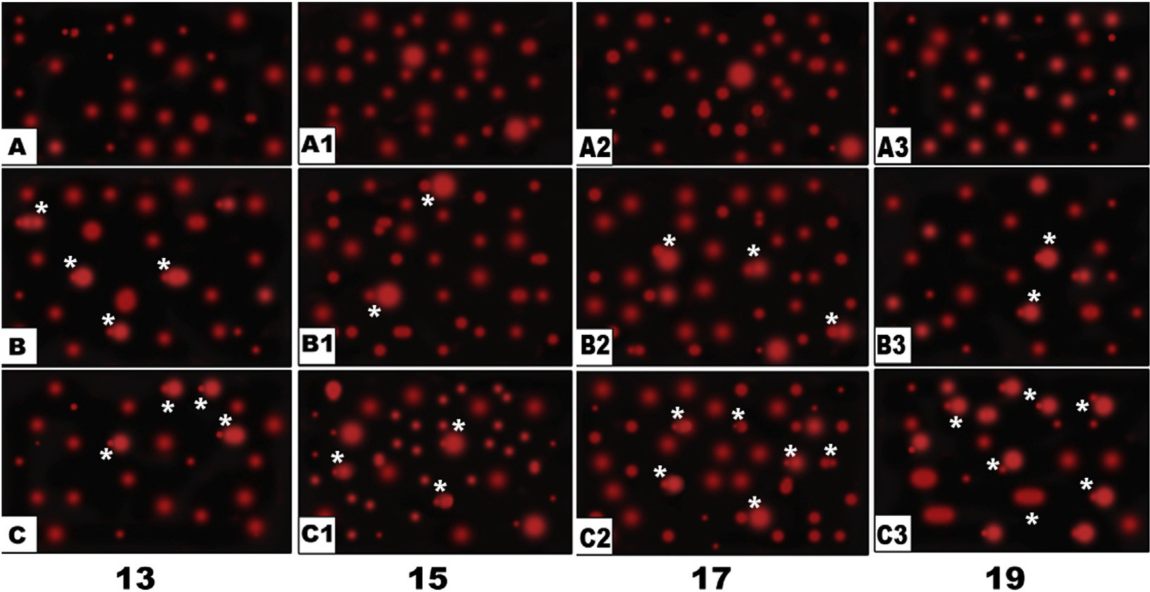

Fig. 11 e Comet assay of hind limb of 13, 15, 17, and 19 d-old fetuses. A, A1, A2, A3 are controls. B, B1, B2, B3 are fetuses maternally diabetic. C, C1, C2, C3 are fetuses maternally hypercholesterolemic. Fetuses of either diabetic or hypercholesterolemic mothers showed stretched bone cells with DNA damage (*).

[e gypti an j o ur nal o f b a sic a n d a pp l i ed sci en c e s 2 ( 201 5 ) 1](http://dx.doi.org/10.1016/j.ejbas.2014.12.003) e[12](http://dx.doi.org/10.1016/j.ejbas.2014.12.003) 11

severe metabolic dysfunction, peroxidation of membrane lipids, oxidative protein damage, alteration of cytoplasmic and nuclear signal transduction, and DNA damage [52].

Takasu et al. [53] stated that DNA fragmentation suppos- edly resulted from the accumulation of superoxide or hy- droxyl radicals.

Also, our findings revealed that defects in blood vessel formation during development of perichondrial and periosteal sheath of the tibia of 15 d-old embryos of diabetic or hyper- cholesterolemic mothers may reduce nutrient and oxygen demands of skeletal elements, decreasing their differentiation and mineralization.

As we know that the risk of peripheral vascular disease is increased in diabetic and hypercholesterolemic patients. Endothelial dysfunction, vascular smooth muscle cell dysfunction, inflammation and hypercoagubility are the key factors for peripheral vascular disease [6,54]. These compli- cations may cause ischemia during bone differentiation and consequently retarded cell growth and development.

Finally, we conclude that maternal diabetes and hyper- cholesterolemia have a selective, dramatic effect during fetus development, altering the histo- and cytological differentia- tion and retarding bone growth. On the other hand, maternal diabetes and hypercholesterolemia increased the rate of cell death in skeletal elements and blood vessels as a result of increased oxidative stress and altered lactic dehydrogenase marker of cell damage in accordance with DNA damage.

1. [El-Sayyad HIH, Al-Haggar MMS, El-Ghawet HA, Bakr IHM.](http://refhub.elsevier.com/S2314-808X(14)00058-X/sref7) [Effect of maternal diabetes and hypercholesterolemia on](http://refhub.elsevier.com/S2314-808X(14)00058-X/sref7) [fetal liver of albino Wistar rats. Nutrition 2014;30:326](http://refhub.elsevier.com/S2314-808X(14)00058-X/sref7)e[36](http://refhub.elsevier.com/S2314-808X(14)00058-X/sref7).
2. [Krakauer JC, McKenna MJ, Buderer NF, Rao DS,](http://refhub.elsevier.com/S2314-808X(14)00058-X/sref8)

[Whitehouse FW, Parfitt AM. Bone loss and bone turnover in](http://refhub.elsevier.com/S2314-808X(14)00058-X/sref8) [diabetes. Diabetes 1995;44:775](http://refhub.elsevier.com/S2314-808X(14)00058-X/sref8)e[82](http://refhub.elsevier.com/S2314-808X(14)00058-X/sref8).

1. [Horcajada-Molteni MN, Chanteranne B, Lebecque P,](http://refhub.elsevier.com/S2314-808X(14)00058-X/sref9) [Davicco MJ, Coxam V, Young A, et al. Amylin and bone](http://refhub.elsevier.com/S2314-808X(14)00058-X/sref9) [metabolism in streptozotocin-induced diabetic rats. J Bone](http://refhub.elsevier.com/S2314-808X(14)00058-X/sref9) [Min Res 2001;16:958](http://refhub.elsevier.com/S2314-808X(14)00058-X/sref9)e[65](http://refhub.elsevier.com/S2314-808X(14)00058-X/sref9).
2. [Lu H, Kraut D, Gerstenfeld LC, Graves DT. Diabetes interferes](http://refhub.elsevier.com/S2314-808X(14)00058-X/sref10) [with the bone formation by affecting the expression of](http://refhub.elsevier.com/S2314-808X(14)00058-X/sref10) [transcription factors that regulate osteoblast differentiation.](http://refhub.elsevier.com/S2314-808X(14)00058-X/sref10) [Endocrinology 2003;144:346](http://refhub.elsevier.com/S2314-808X(14)00058-X/sref10)e[52](http://refhub.elsevier.com/S2314-808X(14)00058-X/sref10).
3. [He H, Liu R, Desta T, Leone C, Gerstenfeld LC, Graves DT.](http://refhub.elsevier.com/S2314-808X(14)00058-X/sref11) [Diabetes causes decreased osteoclastogenesis, reduced bone](http://refhub.elsevier.com/S2314-808X(14)00058-X/sref11) [formation, and enhanced apoptosis of osteoblastic cells in](http://refhub.elsevier.com/S2314-808X(14)00058-X/sref11) [bacteria stimulated bone loss. Endocrinology](http://refhub.elsevier.com/S2314-808X(14)00058-X/sref11) [2004;145:447](http://refhub.elsevier.com/S2314-808X(14)00058-X/sref11)e[52](http://refhub.elsevier.com/S2314-808X(14)00058-X/sref11).
4. [Kayal RA, Tsatsas D, Bauer MA, Allen B, Al-Sebaei MO,](http://refhub.elsevier.com/S2314-808X(14)00058-X/sref12) [Kakar S, et al. Diminished bone formation during diabetic](http://refhub.elsevier.com/S2314-808X(14)00058-X/sref12) [fracture healing is related to the premature resorption of](http://refhub.elsevier.com/S2314-808X(14)00058-X/sref12) [cartilage associated with increased osteoclast activity. J Bone](http://refhub.elsevier.com/S2314-808X(14)00058-X/sref12) [Min Res 2007;22:560](http://refhub.elsevier.com/S2314-808X(14)00058-X/sref12)e[8](http://refhub.elsevier.com/S2314-808X(14)00058-X/sref12).
5. [Won HY, Park JB, Park EY, Riew KD. Effect of hyperglycemia on](http://refhub.elsevier.com/S2314-808X(14)00058-X/sref13) [apoptosis of notochordal cells and intervertebral disc](http://refhub.elsevier.com/S2314-808X(14)00058-X/sref13) [degeneration in diabetic rats. J Neurosurg Spine 2009;11:741](http://refhub.elsevier.com/S2314-808X(14)00058-X/sref13)e[8](http://refhub.elsevier.com/S2314-808X(14)00058-X/sref13).
6. [Jepsen KJ. The aging cortex: to crack or not to crack.](http://refhub.elsevier.com/S2314-808X(14)00058-X/sref14) [Osteoporos Int 2003;14(5):S57](http://refhub.elsevier.com/S2314-808X(14)00058-X/sref14)e[62](http://refhub.elsevier.com/S2314-808X(14)00058-X/sref14).
7. [Fuller K, Murphy C, Kirstein B, Fox SW, Chambers TJ.](http://refhub.elsevier.com/S2314-808X(14)00058-X/sref15) [TNFalpha potently activates osteoclasts, through a direct](http://refhub.elsevier.com/S2314-808X(14)00058-X/sref15) [action independent of and strongly synergistic with RANKL.](http://refhub.elsevier.com/S2314-808X(14)00058-X/sref15) [Endocrinology 2002;143:1108](http://refhub.elsevier.com/S2314-808X(14)00058-X/sref15)e[18](http://refhub.elsevier.com/S2314-808X(14)00058-X/sref15).

[16] [Funaba M, Murata T, Murata E, Abe M, Takahashi M, Torii K.](http://refhub.elsevier.com/S2314-808X(14)00058-X/sref16)

# Competing interests

The authors declare they have no competing interests.

# Funding

There are no funding sources to declare.

## referen c es

1. [Majima T, Shimatsu A, Komatsu Y, Satoh N, Fukao A,](http://refhub.elsevier.com/S2314-808X(14)00058-X/sref1) [Ninomiya K, et al. Increased bone turnover in patients with](http://refhub.elsevier.com/S2314-808X(14)00058-X/sref1) [hypercholesterolemia. Endocr J 2008;5(1):143](http://refhub.elsevier.com/S2314-808X(14)00058-X/sref1)e[51](http://refhub.elsevier.com/S2314-808X(14)00058-X/sref1).
2. [Isidro ML, Ruano B. Bone disease in diabetes. Curr Diabetes](http://refhub.elsevier.com/S2314-808X(14)00058-X/sref2) [Rev 2010;6(3):144](http://refhub.elsevier.com/S2314-808X(14)00058-X/sref2)e[55](http://refhub.elsevier.com/S2314-808X(14)00058-X/sref2).
3. [O'Brien T1, Nguyen TT, Zimmerman BR. Hyperlipidemia and](http://refhub.elsevier.com/S2314-808X(14)00058-X/sref3) [diabetes mellitus. Mayo Clin Proc 1998;73(10):969](http://refhub.elsevier.com/S2314-808X(14)00058-X/sref3)e[76](http://refhub.elsevier.com/S2314-808X(14)00058-X/sref3).
4. [Hwang SM, Kim JS, Lee YJ, Yoon JJ, Lee SM, Kang DG, et al.](http://refhub.elsevier.com/S2314-808X(14)00058-X/sref4) [Anti-diabetic atherosclerosis effect of Prunella vulgaris in db/](http://refhub.elsevier.com/S2314-808X(14)00058-X/sref4) [db mice with type 2 diabetes. Am J Chin Med 2012;40:937](http://refhub.elsevier.com/S2314-808X(14)00058-X/sref4)e[51](http://refhub.elsevier.com/S2314-808X(14)00058-X/sref4).
5. [Prasad K, McNair ED, Qureshi AM, Casper-Bell G. Vitamin E](http://refhub.elsevier.com/S2314-808X(14)00058-X/sref5) [slows the progression of hypercholesterolemia-induced](http://refhub.elsevier.com/S2314-808X(14)00058-X/sref5) [oxidative stress in heart, liver and kidney. Mol Cell Biochem](http://refhub.elsevier.com/S2314-808X(14)00058-X/sref5) [2012;368:181](http://refhub.elsevier.com/S2314-808X(14)00058-X/sref5)e[7](http://refhub.elsevier.com/S2314-808X(14)00058-X/sref5).
6. [El-Sayyad HI, Al-Haggar MS, El-Ghawet HA, Bakr IH.](http://refhub.elsevier.com/S2314-808X(14)00058-X/sref6) [Cardiomyopathy and angiogenesis defects of Wistar rat](http://refhub.elsevier.com/S2314-808X(14)00058-X/sref6) [fetuses of diabetic and hypercholesterolemic mothers.](http://refhub.elsevier.com/S2314-808X(14)00058-X/sref6) [Nutrition 2012;28:33](http://refhub.elsevier.com/S2314-808X(14)00058-X/sref6)e[43](http://refhub.elsevier.com/S2314-808X(14)00058-X/sref6).

[Increased cartilage and bone formation in spontaneously](http://refhub.elsevier.com/S2314-808X(14)00058-X/sref16) [hypercholesterolemic rats. Life Sci 1997;61:645](http://refhub.elsevier.com/S2314-808X(14)00058-X/sref16)e[52](http://refhub.elsevier.com/S2314-808X(14)00058-X/sref16).

1. [Povoski SP, McCullough PJ, Zhou W, Bell Jr RH. Induction of](http://refhub.elsevier.com/S2314-808X(14)00058-X/sref17) [diabetes mellitus in Syrian golden hamsters using stored](http://refhub.elsevier.com/S2314-808X(14)00058-X/sref17) [equilibrium solutions of streptozotocin. Lab Anim Sci](http://refhub.elsevier.com/S2314-808X(14)00058-X/sref17) [1993;43:310](http://refhub.elsevier.com/S2314-808X(14)00058-X/sref17)e[4](http://refhub.elsevier.com/S2314-808X(14)00058-X/sref17).
2. [Enkhmaa B, Shiwaku K, Anuurad E, Nogi A, Kitajima K,](http://refhub.elsevier.com/S2314-808X(14)00058-X/sref18) [Yamasaki M, et al. Prevalence of the metabolic syndrome](http://refhub.elsevier.com/S2314-808X(14)00058-X/sref18) [using the third report of the national cholesterol educational](http://refhub.elsevier.com/S2314-808X(14)00058-X/sref18) [program expert panel on detection, evaluation, and](http://refhub.elsevier.com/S2314-808X(14)00058-X/sref18) [treatment of high blood cholesterol in adults (ATP III) and the](http://refhub.elsevier.com/S2314-808X(14)00058-X/sref18) [modified ATP III definitions for Japanese and Mongolians.](http://refhub.elsevier.com/S2314-808X(14)00058-X/sref18) [Clin Chim Acta 2005;352:105](http://refhub.elsevier.com/S2314-808X(14)00058-X/sref18)e[13](http://refhub.elsevier.com/S2314-808X(14)00058-X/sref18).
3. [Scancar J, Milacic R, Benedik M, Bukovec P. Determination of](http://refhub.elsevier.com/S2314-808X(14)00058-X/sref19) [trace elements and calcium in bone of the human iliac crest](http://refhub.elsevier.com/S2314-808X(14)00058-X/sref19) [by atomic absorption spectrometry. Clin Chim Acta](http://refhub.elsevier.com/S2314-808X(14)00058-X/sref19) [2000;293(1](http://refhub.elsevier.com/S2314-808X(14)00058-X/sref19)e[2):187](http://refhub.elsevier.com/S2314-808X(14)00058-X/sref19)e[92](http://refhub.elsevier.com/S2314-808X(14)00058-X/sref19).
4. [Lehnert T, Berlet HH. Selective inactivation of lactate](http://refhub.elsevier.com/S2314-808X(14)00058-X/sref20) [dehydrogenase of rat tissues by sodium deoxycholate.](http://refhub.elsevier.com/S2314-808X(14)00058-X/sref20) [Biochem J 1979;177:813](http://refhub.elsevier.com/S2314-808X(14)00058-X/sref20)e[8](http://refhub.elsevier.com/S2314-808X(14)00058-X/sref20).
5. [Shaw CR, Prasad R. Starch gel electrophoresis of enzymes](http://refhub.elsevier.com/S2314-808X(14)00058-X/sref21)e[a](http://refhub.elsevier.com/S2314-808X(14)00058-X/sref21) [compilation of recipes. Biochem Genet 1970;4:297](http://refhub.elsevier.com/S2314-808X(14)00058-X/sref21)e[320](http://refhub.elsevier.com/S2314-808X(14)00058-X/sref21).
6. [Sundblad L, Wallin-Nilsson M, Brohult J. Characterization of](http://refhub.elsevier.com/S2314-808X(14)00058-X/sref22) [alkaline phosphatase isoenzymes in serum by agar gel](http://refhub.elsevier.com/S2314-808X(14)00058-X/sref22) [electrophoresis. Clin Chim Acta 1973;45(3):219](http://refhub.elsevier.com/S2314-808X(14)00058-X/sref22)e[23](http://refhub.elsevier.com/S2314-808X(14)00058-X/sref22).
7. [Frazen A, Hasselgren G. Electrophoresis separation of](http://refhub.elsevier.com/S2314-808X(14)00058-X/sref23) [alkaline and acid phosphatase isoenzymes from the pulp of](http://refhub.elsevier.com/S2314-808X(14)00058-X/sref23) [monkey teeth. Acta Odontol Scand 1978;36(6):371](http://refhub.elsevier.com/S2314-808X(14)00058-X/sref23)e[5](http://refhub.elsevier.com/S2314-808X(14)00058-X/sref23).
8. [Duke RC, Sellins CB. Cellular Basis of Immune Modulation.](http://refhub.elsevier.com/S2314-808X(14)00058-X/sref24) [In: Kaplan JG, Green DR, Bleackley RC, editors. 19th](http://refhub.elsevier.com/S2314-808X(14)00058-X/sref24) [International leukocyte culture conference. New York: AR](http://refhub.elsevier.com/S2314-808X(14)00058-X/sref24) [Liss; 1989. p. 311](http://refhub.elsevier.com/S2314-808X(14)00058-X/sref24)e[4](http://refhub.elsevier.com/S2314-808X(14)00058-X/sref24).
9. [Sasaki YF, Saga A, Akasaka M, Yoshida K, Nishidate E, Su YQ,](http://refhub.elsevier.com/S2314-808X(14)00058-X/sref25) [et al. In vivo genotoxicity of ortho-phenylphenol, biphenyl,](http://refhub.elsevier.com/S2314-808X(14)00058-X/sref25)

12 [e gypti an j o ur nal o f b a sic and a pp l i ed sci en c e s 2 ( 201 5 ) 1](http://dx.doi.org/10.1016/j.ejbas.2014.12.003) e[12](http://dx.doi.org/10.1016/j.ejbas.2014.12.003)

[and thiabendazole detected in multiple mouse organs by the](http://refhub.elsevier.com/S2314-808X(14)00058-X/sref25) [alkaline single cell gel electrophoresis assay. Mutat Res](http://refhub.elsevier.com/S2314-808X(14)00058-X/sref25) [1997;395:189](http://refhub.elsevier.com/S2314-808X(14)00058-X/sref25)e[98](http://refhub.elsevier.com/S2314-808X(14)00058-X/sref25).

1. [Heaney RP. The bone-remodeling transient: implications for](http://refhub.elsevier.com/S2314-808X(14)00058-X/sref26) [the interpretation of clinical studies of bone mass change. J](http://refhub.elsevier.com/S2314-808X(14)00058-X/sref26) [Bone Min Res 1994;9:1515](http://refhub.elsevier.com/S2314-808X(14)00058-X/sref26)e[23](http://refhub.elsevier.com/S2314-808X(14)00058-X/sref26).
2. [Polanco Ponce AC, Revilla Monsalve MC, Palomino](http://refhub.elsevier.com/S2314-808X(14)00058-X/sref27)

[Garibay MA, Islas Andrade S. Effect of maternal diabetes on](http://refhub.elsevier.com/S2314-808X(14)00058-X/sref27) [human and rat fetal development. Ginecol Obstet Mex](http://refhub.elsevier.com/S2314-808X(14)00058-X/sref27) [2005;73:544](http://refhub.elsevier.com/S2314-808X(14)00058-X/sref27)e[52](http://refhub.elsevier.com/S2314-808X(14)00058-X/sref27).

1. [Eidem I, Stene LC, Henriksen T, Hanssen KF, Vangen S,](http://refhub.elsevier.com/S2314-808X(14)00058-X/sref28) [Vollset SE, et al. Congenital anomalies in newborns of](http://refhub.elsevier.com/S2314-808X(14)00058-X/sref28) [women with type 1 diabetes: nationwide population-based](http://refhub.elsevier.com/S2314-808X(14)00058-X/sref28) [study in Norway, 1999](http://refhub.elsevier.com/S2314-808X(14)00058-X/sref28)e[2004. Acta Obstet Gynecol Scand](http://refhub.elsevier.com/S2314-808X(14)00058-X/sref28) [2010;89:1403](http://refhub.elsevier.com/S2314-808X(14)00058-X/sref28)e[11](http://refhub.elsevier.com/S2314-808X(14)00058-X/sref28).
2. [El-Sayyad HI, Abou-El-Naga AM, Gadallah AA, Bakr IH.](http://refhub.elsevier.com/S2314-808X(14)00058-X/sref29) [Protective effects of Allium sativum against defects of](http://refhub.elsevier.com/S2314-808X(14)00058-X/sref29) [hypercholesterolemia on pregnant rats and their offspring.](http://refhub.elsevier.com/S2314-808X(14)00058-X/sref29) [Int J Clin Exp Med 2010;3:152](http://refhub.elsevier.com/S2314-808X(14)00058-X/sref29)e[63](http://refhub.elsevier.com/S2314-808X(14)00058-X/sref29).
3. [Garland HO, Forshaw AG, Sibley CP. Dietary essential fatty](http://refhub.elsevier.com/S2314-808X(14)00058-X/sref30) [acid supplementation, urinary calcium excretion and](http://refhub.elsevier.com/S2314-808X(14)00058-X/sref30) [reproductive performance in the diabetic pregnant rat. J](http://refhub.elsevier.com/S2314-808X(14)00058-X/sref30) [Endocrinol 1997;153:357](http://refhub.elsevier.com/S2314-808X(14)00058-X/sref30)e[63](http://refhub.elsevier.com/S2314-808X(14)00058-X/sref30).
4. [Husain SM, Birdsey TJ, Glazier JD, Mughal MZ, Garland HO,](http://refhub.elsevier.com/S2314-808X(14)00058-X/sref31) [Sibley CP. Effect of diabetes mellitus on maternofetal flux of](http://refhub.elsevier.com/S2314-808X(14)00058-X/sref31) [calcium and magnesium and calbindin9K mRNA expression](http://refhub.elsevier.com/S2314-808X(14)00058-X/sref31) [in rat placenta. Pediatr Res 1994;35:376](http://refhub.elsevier.com/S2314-808X(14)00058-X/sref31)e[81](http://refhub.elsevier.com/S2314-808X(14)00058-X/sref31).
5. [Verhaeghe J, Van Herck E, Bouillon R. Umbilical cord](http://refhub.elsevier.com/S2314-808X(14)00058-X/sref32) [osteocalcin in normal pregnancies and pregnancies](http://refhub.elsevier.com/S2314-808X(14)00058-X/sref32) [complicated by fetal growth retardation or diabetes mellitus.](http://refhub.elsevier.com/S2314-808X(14)00058-X/sref32) [Biol Neonate 1995;68:377](http://refhub.elsevier.com/S2314-808X(14)00058-X/sref32)e[83](http://refhub.elsevier.com/S2314-808X(14)00058-X/sref32).
6. [Funk JR, Hale JE, Carmines D, Gooch HL, Hurwitz SR.](http://refhub.elsevier.com/S2314-808X(14)00058-X/sref33) [Biomechanical evaluation of early fracture healing in normal](http://refhub.elsevier.com/S2314-808X(14)00058-X/sref33) [and diabetic rats. J Orthop Res 2000;18:126](http://refhub.elsevier.com/S2314-808X(14)00058-X/sref33)e[32](http://refhub.elsevier.com/S2314-808X(14)00058-X/sref33).
7. [Dost A, Rohrer T, Fussenegger J, Vogel C, Schenk B,](http://refhub.elsevier.com/S2314-808X(14)00058-X/sref34) [Wabitsch M, et al. Bone maturation in 1788 children and](http://refhub.elsevier.com/S2314-808X(14)00058-X/sref34) [adolescents with diabetes mellitus type 1. J Pediatr](http://refhub.elsevier.com/S2314-808X(14)00058-X/sref34) [Endocrinol Metab 2010;23:891](http://refhub.elsevier.com/S2314-808X(14)00058-X/sref34)e[8](http://refhub.elsevier.com/S2314-808X(14)00058-X/sref34).
8. [Tolosa MJ, Chuguransky SR, Sedlinsky C, Schurman L,](http://refhub.elsevier.com/S2314-808X(14)00058-X/sref35) [McCarthy AD, Molinuevo MS, et al. Insulin-deficient](http://refhub.elsevier.com/S2314-808X(14)00058-X/sref35) [diabetes-induced bone microarchitecture alterations are](http://refhub.elsevier.com/S2314-808X(14)00058-X/sref35) [associated with a decrease in the osteogenic potential of](http://refhub.elsevier.com/S2314-808X(14)00058-X/sref35) [bone marrow progenitor cells: preventive effects of](http://refhub.elsevier.com/S2314-808X(14)00058-X/sref35) [metformin. Dib Res Clin Prac 2013:177](http://refhub.elsevier.com/S2314-808X(14)00058-X/sref35)e[86](http://refhub.elsevier.com/S2314-808X(14)00058-X/sref35).
9. [Gopalakrishnan V, Arunakaran J, Aruldhas MM,](http://refhub.elsevier.com/S2314-808X(14)00058-X/sref36)

[Srinivasan N. Effects of streptozotocin-induced diabetes](http://refhub.elsevier.com/S2314-808X(14)00058-X/sref36) [mellitus on some bone turnover markers in the vertebrae of](http://refhub.elsevier.com/S2314-808X(14)00058-X/sref36) [ovary-intact and ovariectomized adult rats. Biochem Cell](http://refhub.elsevier.com/S2314-808X(14)00058-X/sref36) [Biol 2006;84(5):728](http://refhub.elsevier.com/S2314-808X(14)00058-X/sref36)e[36](http://refhub.elsevier.com/S2314-808X(14)00058-X/sref36).

1. [Zangen SW, Yaffe P, Shechtman S, Zangen DH, Ornoy A. The](http://refhub.elsevier.com/S2314-808X(14)00058-X/sref37) [role of reactive oxygen species in diabetes-induced](http://refhub.elsevier.com/S2314-808X(14)00058-X/sref37) [anomalies in embryos of Cohen diabetic rats. Int J Exp](http://refhub.elsevier.com/S2314-808X(14)00058-X/sref37) [Diabetes Res 2002;3:247](http://refhub.elsevier.com/S2314-808X(14)00058-X/sref37)e[55](http://refhub.elsevier.com/S2314-808X(14)00058-X/sref37).
2. [Eriksson JG, Yliharsila H, Forsen T, Osmond C, Barker DJ.](http://refhub.elsevier.com/S2314-808X(14)00058-X/sref38) [Exercise protects against glucose intolerance in individuals](http://refhub.elsevier.com/S2314-808X(14)00058-X/sref38) [with a small body size at birth. Prev Med 2004;39:164](http://refhub.elsevier.com/S2314-808X(14)00058-X/sref38)e[7](http://refhub.elsevier.com/S2314-808X(14)00058-X/sref38).
3. [Viccica G, Vignali E, Marcocci C. Role of the cholesterol](http://refhub.elsevier.com/S2314-808X(14)00058-X/sref39) [biosynthetic pathway in osteoblastic differentiation. J](http://refhub.elsevier.com/S2314-808X(14)00058-X/sref39) [Endocrinol Invest 2007;30:8](http://refhub.elsevier.com/S2314-808X(14)00058-X/sref39)e[12](http://refhub.elsevier.com/S2314-808X(14)00058-X/sref39).
4. [Nakano A, Kanda T, Abe H. Bone changes and mineral](http://refhub.elsevier.com/S2314-808X(14)00058-X/sref40) [metabolism disorders in rats with experimental liver](http://refhub.elsevier.com/S2314-808X(14)00058-X/sref40) [cirrhosis. J Gastroenterol Hepatol 1996;11(12):1143](http://refhub.elsevier.com/S2314-808X(14)00058-X/sref40)e[54](http://refhub.elsevier.com/S2314-808X(14)00058-X/sref40).
5. [Hollis BW. Assessment of vitamin D nutritional and](http://refhub.elsevier.com/S2314-808X(14)00058-X/sref41) [hormonal status: what to measure and how to do it. Calcif](http://refhub.elsevier.com/S2314-808X(14)00058-X/sref41) [Tissue Int 1996;58(1):4](http://refhub.elsevier.com/S2314-808X(14)00058-X/sref41)e[5](http://refhub.elsevier.com/S2314-808X(14)00058-X/sref41).
6. [Nair S. Vitamin D deficiency and liver disease.](http://refhub.elsevier.com/S2314-808X(14)00058-X/sref42) [Gastroenterology Hepatology 2010;6(8):491](http://refhub.elsevier.com/S2314-808X(14)00058-X/sref42)e[3](http://refhub.elsevier.com/S2314-808X(14)00058-X/sref42).
7. [Allen M, Millett P, Dawes E, Rushton N. Lactate](http://refhub.elsevier.com/S2314-808X(14)00058-X/sref43) [dehydrogenase activity as a rapid and sensitive test for the](http://refhub.elsevier.com/S2314-808X(14)00058-X/sref43) [quantification of cell numbers *in vitro*. Clin Mater](http://refhub.elsevier.com/S2314-808X(14)00058-X/sref43) [1994;16(4):189](http://refhub.elsevier.com/S2314-808X(14)00058-X/sref43)e[94](http://refhub.elsevier.com/S2314-808X(14)00058-X/sref43).
8. [Wong SYP, Dunstan CR, Evans RA, Hills E. The determination](http://refhub.elsevier.com/S2314-808X(14)00058-X/sref44) [bone viability: a histochemical method for identification of](http://refhub.elsevier.com/S2314-808X(14)00058-X/sref44) [lactate dehydrogenase activity in osteocytes in fresh calcified](http://refhub.elsevier.com/S2314-808X(14)00058-X/sref44) [and decalcified sections of human bone. Pathology](http://refhub.elsevier.com/S2314-808X(14)00058-X/sref44) [1982;14(4):430](http://refhub.elsevier.com/S2314-808X(14)00058-X/sref44)e[42](http://refhub.elsevier.com/S2314-808X(14)00058-X/sref44).
9. [Fullmer HM. Dehydrogenases in developing bone in the rat. J](http://refhub.elsevier.com/S2314-808X(14)00058-X/sref45) [Histochem Cytochem 1964;12(3):210](http://refhub.elsevier.com/S2314-808X(14)00058-X/sref45)e[4](http://refhub.elsevier.com/S2314-808X(14)00058-X/sref45).
10. [Py G, Lambert K, Milhavet O, Eydoux N, Prefaut C, Mercier J.](http://refhub.elsevier.com/S2314-808X(14)00058-X/sref46) [Effects of streptozotocin-induced diabetes on markers of](http://refhub.elsevier.com/S2314-808X(14)00058-X/sref46) [skeletal muscle metabolism and monocarboxylate](http://refhub.elsevier.com/S2314-808X(14)00058-X/sref46) [transporter 1 to monocarboxylate transporter 4 transporters.](http://refhub.elsevier.com/S2314-808X(14)00058-X/sref46) [Metabolism 2002;51:807](http://refhub.elsevier.com/S2314-808X(14)00058-X/sref46)e[13](http://refhub.elsevier.com/S2314-808X(14)00058-X/sref46).
11. [Ohlsson C, Isgaard J, T](http://refhub.elsevier.com/S2314-808X(14)00058-X/sref47)o€[nell T, Nilsson A, Isaksson OGP,](http://refhub.elsevier.com/S2314-808X(14)00058-X/sref47) [Lindahl A. Endocrine regulation of longitudinal bone growth.](http://refhub.elsevier.com/S2314-808X(14)00058-X/sref47) [Acta Paediatr 1993;(Suppl. 391):33](http://refhub.elsevier.com/S2314-808X(14)00058-X/sref47)e[40](http://refhub.elsevier.com/S2314-808X(14)00058-X/sref47).
12. [Wergedal JE, Baylink DJ. Distribution of acid and alkaline](http://refhub.elsevier.com/S2314-808X(14)00058-X/sref48) [phosphatase activity in undemineralized sections of the rat](http://refhub.elsevier.com/S2314-808X(14)00058-X/sref48) [tibia diaphysis. J Histochem Cytochem 1969;17(12):799](http://refhub.elsevier.com/S2314-808X(14)00058-X/sref48)e[806](http://refhub.elsevier.com/S2314-808X(14)00058-X/sref48).
13. [Tsur A, Feldman BS, Feldhammer I, Hoshen MB, Leibowitz G,](http://refhub.elsevier.com/S2314-808X(14)00058-X/sref49) [Balicer RD. Decreased serum concentrations of 25-](http://refhub.elsevier.com/S2314-808X(14)00058-X/sref49) [hydroxycholecalciferol are associated with increased risk of](http://refhub.elsevier.com/S2314-808X(14)00058-X/sref49) [progression to impaired fasting glucose and diabetes.](http://refhub.elsevier.com/S2314-808X(14)00058-X/sref49) [Diabetes Care 2013;36(5):1361](http://refhub.elsevier.com/S2314-808X(14)00058-X/sref49)e[7](http://refhub.elsevier.com/S2314-808X(14)00058-X/sref49).
14. [Gupta GK, Agrawal T, DelCore MG, Mohiuddin SM,](http://refhub.elsevier.com/S2314-808X(14)00058-X/sref50) [Agrawal DK. Vitamin D deficiency induces cardiac](http://refhub.elsevier.com/S2314-808X(14)00058-X/sref50) [hypertrophy and inflammation in epicardial adipose tissue](http://refhub.elsevier.com/S2314-808X(14)00058-X/sref50) [in hypercholesterolemic swine. Exp Mol Pathol](http://refhub.elsevier.com/S2314-808X(14)00058-X/sref50) [2012;93(1):82](http://refhub.elsevier.com/S2314-808X(14)00058-X/sref50)e[90](http://refhub.elsevier.com/S2314-808X(14)00058-X/sref50).
15. [Lodovici M, Giovannelli L, Pitozzi V, Bigagli E, Bardini G,](http://refhub.elsevier.com/S2314-808X(14)00058-X/sref51) [Rotella CM. Oxidative DNA damage and plasma antioxidant](http://refhub.elsevier.com/S2314-808X(14)00058-X/sref51) [capacity in type 2 diabetic patients with good and poor](http://refhub.elsevier.com/S2314-808X(14)00058-X/sref51) [glycaemic control. Mutat Res 2008;638:98](http://refhub.elsevier.com/S2314-808X(14)00058-X/sref51)e[102](http://refhub.elsevier.com/S2314-808X(14)00058-X/sref51).
16. [Ishii N, Ogawa Z, Suzuki K, Numakami K, Saruta T, Itoh H.](http://refhub.elsevier.com/S2314-808X(14)00058-X/sref52) [Glucose loading induces DNA fragmentation in rat proximal](http://refhub.elsevier.com/S2314-808X(14)00058-X/sref52) [tubular cells. Metabolism 1996;45:1348](http://refhub.elsevier.com/S2314-808X(14)00058-X/sref52)e[53](http://refhub.elsevier.com/S2314-808X(14)00058-X/sref52).
17. [Takasu N, Komiya I, Asawa T, Nagasawa Y, Yamada T.](http://refhub.elsevier.com/S2314-808X(14)00058-X/sref53) [Streptozocin- and alloxan-induced H2O2](http://refhub.elsevier.com/S2314-808X(14)00058-X/sref53) [generation and DNA](http://refhub.elsevier.com/S2314-808X(14)00058-X/sref53) [fragmentation in pancreatic islets. H2O2](http://refhub.elsevier.com/S2314-808X(14)00058-X/sref53) [as mediator for DNA](http://refhub.elsevier.com/S2314-808X(14)00058-X/sref53) [fragmentation. Diabetes 1991;40:1141](http://refhub.elsevier.com/S2314-808X(14)00058-X/sref53)e[5](http://refhub.elsevier.com/S2314-808X(14)00058-X/sref53).
18. [Huysman E, Mathieu C. Diabetes and peripheral vascular](http://refhub.elsevier.com/S2314-808X(14)00058-X/sref54) [disease. Acta Chir Belg 2009;109(5):587](http://refhub.elsevier.com/S2314-808X(14)00058-X/sref54)e[94](http://refhub.elsevier.com/S2314-808X(14)00058-X/sref54).